**DIABETIC RETINOPATHY DETECTION & CLASSIFICATION**

*submitted in partial fulfilment of the requirement for the degree of*

**BACHELOR OF ENGINEERING**

in

#### Electronics and Computers Engineering

by

### Charvi Sofat 102115001

**Pratinav Batra 102115004**

### Varun Kashyap 102115012

**Paras Sharma 102115015**

### Vaibhav Kalra 102115104

under the supervision of

**Dr. Arnab Pattanayak (Assistant Professor, ECED)**

**Dr. Ram Kishan Dewangan (Assistant Professor, ECED)**



**DEPARTMENT OF ELECTRONICS AND COMMUNICATION ENGINEERING**

**THAPAR INSTITUTE OF ENGINEERING & TECHNOLOGY PATIALA**

**October 2024**

# DECLARATION

We declare that this written submission represents our ideas in our own words and where others’ ideas or words have been included, we have adequately cited and referenced the original sources. We also declare that we have adhered to all principles of academic honesty and integrity and have not misrepresented or fabricated or falsified any idea/- data/fact/source in our submission to the best of my knowledge. We understand that any violation of the above will be cause for disciplinary action by the Institute and can also evoke penal action from the sources which have thus not been properly cited or from whom proper permission has not been taken when needed.

Place: Patiala

Date: 25-10-2024

|  |  |  |
| --- | --- | --- |
| Charvi Sofat | 102115001 |  |
| Pratinav Batra | 102115004 |  |
| Varun Kashyap | 102115012 |  |
| Paras Sharma | 102115015 |  |
| Vaibhav Kalra | 102115104 |  |

## CERTIFICATE

## This is to certify that the report titled DIABETIC RETINOPATHY DETECTION & CLASSIFICATION REPORT, submitted by Charvi Sofat, Pratinav Batra, Varun Kashyap, Paras Sharma & Vaibhav Kalra to the Thapar Institute of Engineering & Technology, Patiala, for the award of the degree of Bachelor of Technology, is a record of the project work done by them under our supervision. The contents of this report, in full or in parts, have not been submitted to any other Institute or University for the award of any degree or diploma.

#### Place: Patiala Dr Arnab Pattanayak

## Date: 25-10-2024 Assistant Professor, ECED

## Dr Ram Kishan Dewangan

## Assistant Professor, ECED

## TIET Patiala - 147004

**ACKNOWLEDGEMENT**

We would like to express our thanks to our mentor **Dr Arnab Pattanayak** and **Dr Ram Kishan Dewangan**. They have been of great help in our venture, and an indispensable resource of technical knowledge. They are truly amazing mentors to have. We are also thankful to Dr. Kulbir Singh, Head, Electronics and Communication Engineering Department, entire faculty and staff Electronics and Communication Engineering Department, and also our friends who devoted their valuable time and helped us in all possible ways towards successful completion of this project. We thank all those who have contributed either directly or indirectly towards this project. Lastly, we would also like to thank our families for their unyielding love and encouragement. They always wanted the best for us and we admire their determination and sacrifice.

## ABSTRACT

Diabetic Retinopathy is a common eye disease and a leading cause of blindness in diabetic patients. Regular screening with fundus photography and timely intervention is the most effective way to manage the disease. The large population of diabetic patients and their massive screening requirements have generated interest in a computer-aided and fully automatic diagnosis of DR. Deep neural networks, on the other hand, have brought many breakthroughs in various tasks in recent years. To automate the diagnosis of DR and provide appropriate suggestions to DR patients, we plan to train a deep convolutional neural network model to grade the severities of DR fundus images. To complete this task our first aim was to find the dataset comprising fundus images of eye. After finding, there was a need for a lot of pre-processing on these images as these images were of different size, colours and shapes. After preprocessing we will move towards the training phase of our CNN model using preprocessed images. We plan to achieve an accuracy greater than 70% for a five-degree classification task in the experiments. We further plan to deploy our model on the web and provide DR diagnostic services for the user.

# TABLE OF CONTENTS

DECLARATION ii

CERTIFICATE iii

ACKNOWLEDGEMENT iv

ABSTRACT v

LIST OF TABLES viii

LIST OF FIGURES ix

LIST OF ABBREVIATIONS x

CHAPTER 1- INTRODUCTION 1

* 1. [PROJECT OVERVIEW](https://docs.google.com/document/d/1VBnLJQRiACM3bZHzjV1NJlxMn4JJW27n/edit#heading%3Dh.3dy6vkm) 1
  2. [MOTIVATION…](https://docs.google.com/document/d/1VBnLJQRiACM3bZHzjV1NJlxMn4JJW27n/edit#heading%3Dh.1t3h5sf) 3
  3. [ASSUMPTIONS AND CONSTRAINTS](https://docs.google.com/document/d/1VBnLJQRiACM3bZHzjV1NJlxMn4JJW27n/edit#heading%3Dh.4d34og8) 5
  4. [NOVELTY OF WORK](https://docs.google.com/document/d/1VBnLJQRiACM3bZHzjV1NJlxMn4JJW27n/edit#heading%3Dh.2s8eyo1) 6

[CHAPTER 2 – LITERATURE SURVEY](https://docs.google.com/document/d/1VBnLJQRiACM3bZHzjV1NJlxMn4JJW27n/edit#heading%3Dh.17dp8vu) 8

* 1. [LITERATURE SURVEY](https://docs.google.com/document/d/1VBnLJQRiACM3bZHzjV1NJlxMn4JJW27n/edit#heading%3Dh.3rdcrjn) 8
  2. [RESEARCH GAPS](https://docs.google.com/document/d/1VBnLJQRiACM3bZHzjV1NJlxMn4JJW27n/edit#heading%3Dh.26in1rg) 20

**CHAPTER 3- PROBLEM FORMULATION AND OBJECTIVES 21**

CHAPTER 4 – PROJECT DESIGN AND DESCRIPTION… 23

* 1. DESCRIPTION 23
  2. SYSTEM ARCHITECTURE 24
  3. TECHNOLOGIES USED 27
  4. U.G SUBJECTS 28
  5. STANDARDS USED 29

CHAPTER 5 – OUTCOME AND PROSPECTIVE LEARNING 31

* 1. SCOPE AND OUTCOMES… 31
  2. PROSPECTIVE LEARNINGS 32
  3. CONCLUSION 33

CHAPTER 6 – PROJECT TIMELINE… 34

* 1. WORK BREAKDOWN 34
  2. PROJECT TIMELINE 35
  3. INDIVISUAL GANTT CHART 36

**CHAPTER 7 - CONCLUSION AND FUTURE WORK 37**

7.1 CONCLUSIONS 37

7.2 ENVIRONMENTAL, ECONOMIC AND SOCIAL BENEFITS 37

7.3 FUTURE WORK 38

REFERENCES 39

**LIST OF TABLES**

|  |  |  |
| --- | --- | --- |
| **Table No.** | **Caption** | **Page**  **No.** |
| Table 1.1 | Constraints | 5 |
| Table 1.2 | Assumptions | 5 |
| Table 2.1 | Types and features of different DR | 12 |
| Table 2.2 | Research finding for existing literature | 14 |
| Table 6.1 | Project timeline | 35 |
| Table 6.2 | Individual work breakdown | 36 |

# 

# LIST OF FIGURES

|  |  |  |
| --- | --- | --- |
| **Figure No.** | **Caption** | **Page No.** |
| 1.1 | Global DR market growth trend | 2 |
| 1.2 | Global DR market distribution (%) by region, 2023 | 2 |
| 1.3 | Future predictive and analytical vision of disease | 3 |
| 2.1 | Mild NPDR | 9 |
| 2.2 | Moderate NPDR | 10 |
| 2.3 | Severe NPDR | 10 |
| 2.4 | Proliferative DR | 11 |
| 2.5 | DR conditions | 11 |
| 4.1 | Data Flow | 23 |
| 4.2 | Three tier architecture | 24 |
| 4.3 | Sequence diagram | 24 |
| 4.4 | Activity diagram | 25 |
| 4.5 | Class diagram | 25 |
| 4.6 | State chart diagram | 26 |
| 4.7 | User interface diagram | 27 |
| 6.1 | Work breakdown structure | 34 |

**LIST OF ABBREVIATIONS**

|  |  |
| --- | --- |
| **TIET** | Thapar Institute of Engineering and Technology |
| **ECE** | Electronics and Communication Engineering |
| **DR** | Diabetic Retinopathy |
| **T2DM** | Type 2 Diabetes Mellitus |
| **WHO** | World Health Organization |
| **US** | United States |
| **NPDR** | Non-Proliferative Diabetic Retinopathy |
| **PDR** | Proliferative Diabetic Retinopathy |
| **CNN** | Convolutional Neural Networks |
| **HTML** | HyperText Markup Language |
| **CSS** | Cascading Style Sheets |
| **JS** | JavaScript |
| **SRS** | Software Requirements Specification |
| **MAs** | Microaneurysms |
| **PCP** | Primary Care Physician/ Provider |
| **IRMA** | IntraRetinal Microvascular Abnormalities |
| **ANN** | Artificial Neural Network |
| **SRS** | Software Requirement Specification |
| **Colab** | Google Colaboratory |
| **DME** | Diabetic Macular Edema |
| **ADA** | American Diabetes Association |

# CHAPTER 1 INTRODUCTION



### Project Overview

**Diabetic retinopathy** (DR) is a vascular disease of the retina which affects patients with diabetes mellitus. It is the number one cause of blindness in people between the ages of 20- 64 [1, p. 112]. Listed amongst WHO’s Top 10 list of priority eye diseases, it is a relatively unnoticed micro-vascular complication in developing countries, especially India, where the maximum number of T2DM patients are living.

The likelihood of developing DR is related to the duration of the disease. Type 2 diabetes has an insidious onset and can go unnoticed for years. As a result, patients may already have DR at the time of diagnosis. Type 1 diabetics, on the other hand, are diagnosed early in the course of their disease, and they typically do not develop retinopathy until years after the diagnosis. The risk of developing retinopathy increases after puberty. Twenty years after the diagnosis, 80% of type 2 diabetics and nearly all type 1 diabetics show some signs of retinopathy

While these numbers are eye-opening, diabetics can decrease the risk of retinopathy and slow the progression of the disease after it has begun with tight glucose control. Glucose control also has the added benefit of decreasing risk for other end-organ complications of diabetes, so it is important that diabetic patients are educated on the topic. Time since diagnosis and extent of hyperglycemia are the most significant risk factors for the DR, but other risk factors for development and progression include hypertension, dyslipidemia, smoking, nephropathy, and pregnancy

Irrespective of the technological advancements in various effective treatments available today to prevent the severe stages, the number of trained ophthalmologists able to diagnose retinal scans and the availability of good medical treatment facilities is far outweighed by the global burden of disease.

Globally, an estimated 422 million adults were living with diabetes in 2014, compared to 108 million in 1980. The global prevalence (age-standardized) of diabetes has nearly doubled since 1980, rising from 4.7% to 8.5% in the adult population. Increasing prevalence 5 of diabetes along with growing incidence of blindness due to diabetes is anticipated to propel the market growth over the forecast period. Statistical representation of this data is given in Fig 1.1 & Fig 1.2.

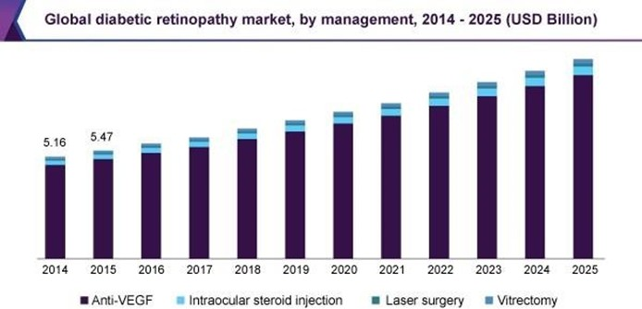

**Fig 1.1: Global DR market growth trend**

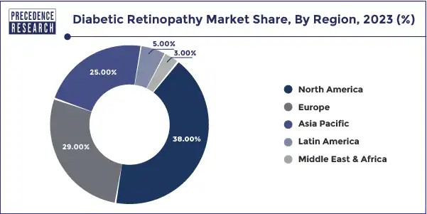

**Fig 1.2: Global DR market distribution (%), by region, of year 2023**

Diabetes is a global epidemic and DR, the commonest microvascular complication of diabetes, is an emerging cause of visual impairment and blindness. It is estimated that by 2040, 642 million people will have diabetes, 35% (224 million) of them will have some form of DR, and 11% (70 million) will have sight-threatening retinopathy as shown in figure 1.3. The Vision Loss Expert Group reported that, despite global efforts, the prevalence of DR increased by 25% between 1990 and 2015, while the prevalence of other causes of visual impairment have decreased. This disparity is due to a rise in the world’s population, an increase in the numbers of people with diabetes, increased longevity and ageing populations. It is, therefore, a worthwhile topic to review for all medical and technological field students globally.

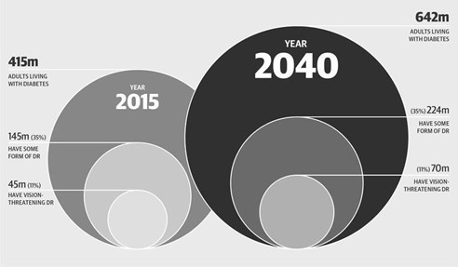

**Fig 1.3: Future predictive and analytical vision of disease**

### Motivation

DR is one of the leading causes of blindness in the world. Among individuals with diabetes, the prevalence of DR is approximately 28.5% in the US and 18% in India.

While early DR usually does not have any symptoms, the later stages can cause blindness and even give rise to various other diseases.

To treat advanced DR, injecting medications into the eye might be needed. These medications, called vascular endothelial growth factor inhibitors, are injected into the vitreous of the eye. They help stop the growth of new blood vessels and decrease fluid buildup. Two drugs are approved by the U.S. Food & Drug Administration (FDA) for the treatment of diabetic macular oedema – ranibizumab (Lucentis) and aflibercept (Eylea). Ranibizumab is known to have side effects like eye pain, decrease or vision changes, bleeding in or around the eye and chest pain. Aflibercept injection has many similar side effects. Patients with mild and moderate/ severe retinopathy had 81% and 314% increased risks of all-cause mortality, respectively. It’s absolutely imperative, therefore, to diagnose the disease in its early stages to mitigate the damage as much as possible, and this project aims to do just that.

Traditionally, the classification of DR involves weighing numerous features and then

locating such features. This is highly time-consuming for clinicians. Retinal photograph with medical interpretation is a widely accepted screening tool for DR. Computers can

obtain quicker classifications once trained. Automated grading of DR has potential benefits such as increasing efficiency, reproducibility, reducing barriers to access, and improving patient outcomes by providing early detection and treatment. Thus, to maximize the clinical utility of automated grading, an algorithm to detect referable DR is required. The project also needs to enable patients to get checked for DR remotely. This can be vital in times when in-person evaluation cannot be done or is not preferred.

Also – as the general problem being solved here is that of image processing of blood vessels by making a few changes to the project’s CNN model, we should be able to detect various other diseases involving blood vessel abnormalities, like blood clots, brain aneurysms and abnormal blood vessel knots.

### Assumptions and constraints

In Table 1.1 and Table 1.2, we pointed out various constraints as well as assumptions which are required for our model to work smoothly.

**Table 1.1: Constraints**

|  |  |
| --- | --- |
| **S. No.** | **Constraints** |
| **1** | The categorization will happen at an accuracy of 70– 90%. |
| **2** | Since the image will not be stored in the database, the user would have to upload it again to see results. |
| **3** | The size of the image should be less than 10 MB. |
| **4** | The website can take up to 15 seconds and at least a second to revert with results. |

**Table 1.2: Assumptions**

|  |  |
| --- | --- |
| **S. No.** | **Assumptions** |
| **1** | Since the application is a web-based application, there is a need for the internet browser. It will be assumed that the users will possess decent internet connectivity. |
| **2** | A standard form of retina image is assumed. |
| **3** | It is assumed that the user is familiar with an  internet browser and also familiar with handling the keyboard and mouse. |
| **4** | Users have access to a device with adequate hardware and software requirements to be able to access internet and store and upload images. If the device does not have enough hardware resources available for the application, for example, the users might have allocated them with other applications, there may be scenarios where the application does not work as intended or even at all. |
| **5** | A modern browser able to run advanced HTML, CSS, JS scripts |
| **6** | Retina images alone are sufficient to determine the stage of DR that a patient is currently suffering from. |

### Novelty of work

This interdisciplinary project combines machine learning, image recognition, medical procedures and web development to concoct a product that helps patients get diagnosed more easily and quickly. All of the aforementioned fields have had years of work put into them, and this project strives to use them together to solve a new problem. It is this reaching out to different branches of knowledge that makes this project unique.

**Deep Learning Integration**: We have developed a novel deep learning algorithm that significantly improves the accuracy of early diabetic retinopathy detection. This algorithm utilizes a comprehensive and diverse dataset, allowing for more robust and generalizable diagnostic capabilities.

**Multi-Modal Imaging**: By integrating high-resolution OCT with traditional fundus photography, our approach offers a multi-modal diagnostic tool that enhances the precision of detecting subtle retinal changes associated with DR.

In summary, this work not only advances the current diagnostic and treatment methodologies for diabetic retinopathy but also sets the stage for future innovations in early detection and personalized care. By addressing the limitations of existing practices, our study aims to significantly improve patient outcomes and reduce the global burden of diabetic retinopathy.

# CHAPTER 2 LITERATURE SURVEY



### Literature survey

#### Theory Associated with Problem Area

Overview of the disease

Diabetes is a disease that occurs when your blood glucose, also called blood sugar, is too high. Blood glucose is your main source of energy and comes from the food you eat. Insulin, a hormone made by the pancreas, helps glucose from food get into your cells to be used for energy. WHO in its Global Diabetes Report has explained DR in simple words. Sometimes your body makes insufficient insulin or no insulin at all. Glucose then stays in your blood and doesn’t reach your cells. The blood vessels that nourish the retina are damaged by the increased glucose level. Over time, too much sugar in your blood can lead to the blockage of the tiny blood vessels that nourish the retina, cutting off its blood supply. As a result, the eye attempts to grow new blood vessels. But these new blood vessels don’t develop properly and can leak easily.

Types of Diabetes:

The American Diabetes Association classifies diabetes into the following general categories:

* Type 1 Diabetes: In type 1 diabetes, the body does not produce insulin. It is believed to be an autoimmune condition. This means your immune system mistakenly attacks and destroys the beta cells in your pancreas that produce insulin. The damage is permanent.
* Type 2 Diabetes: Type 2 diabetes starts as insulin resistance. This means your body can’t use insulin efficiently. That stimulates your pancreas to produce more insulin until it can no longer keep up with demand. Insulin production decreases, which leads to high blood sugar.
* Gestational Diabetes: Gestational diabetes is due to insulin-blocking hormones produced during pregnancy. This type of diabetes only occurs during pregnancy.

Stages of DR:

* **Mild NPDR:** These patients have at least one MA but no other findings. Findings are often subtle, so close inspection and monitoring are essential. If one or more MAs are present in the eye of a patient not yet diagnosed with diabetes, he or she should be considered a diabetes suspect and should see his or her PCP for further testing. Documenting subtle findings and noting their exact locations will help you to monitor patients for disease progression. Use fundus photography, if available, for easier future comparison. In Fig 2.1, Mild NPDR is shown for better understanding.

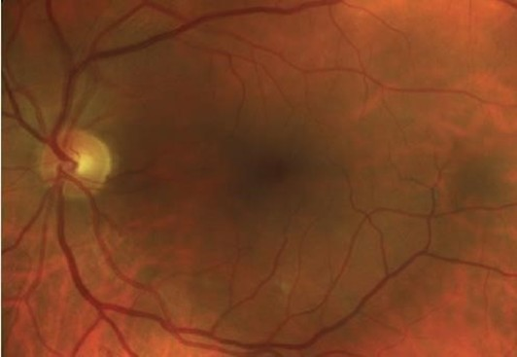

Fig 2.1 **Mild NPDR**

* **Moderate NPDR:** These patients have hemorrhages or MAs in one to three retinal quadrants and/ or cotton wool spots, hard exudates, or venous beading. This is also non proliferative retinopathy. Numerous MAs and retinal hemorrhages are present. Cotton wool spots and a limited amount of venous beading can also be seen. Some blood vessels are starting to become blocked. In Fig 2.2, Moderate NPDR can be seen.

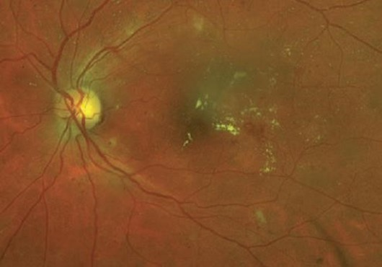

Fig 2.2 **Moderate NPDR**

* **Severe NPDR:** These patients have intraretinal hemorrhages (>20 in each quadrant), venous beading in two or more quadrants, or an IRMA in one or more quadrants. Other features are also present except less growth of new blood vessels; many more blood vessels are now blocked and these areas of retina start to send signals to the body to grow new blood vessels for nourishment. These patients are at a high risk of disease progression and permanent vision loss, and they are most likely experiencing neuropathy elsewhere at this point. Visualization of severe NPDR is given in Fig 2.3.

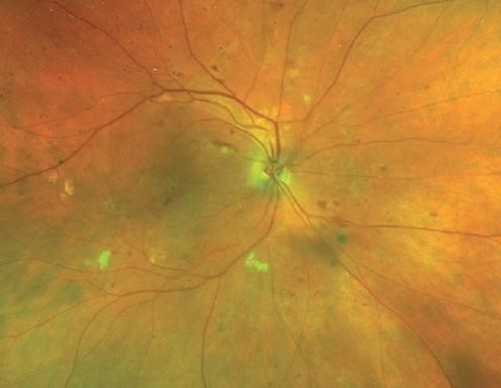

Fig 2.3 **Severe NPDR**

* **Proliferative DR:** These patients had NPDR that has progressed to PDR, and they exhibit either neovascularization of the disc/ elsewhere or vitreous/ preretinal hemorrhage. This is the advanced stage where the fluids sent by the retina for nourishment trigger the growth of new blood vessels. The main blood vessels become stiff, and blockage of blood flow occurs. A small packet of blood begins to form around the boundary of the main blood vessels resulting in sudden severe vision loss and blindness. Fig 2.4 gives a better understanding of how a proliferative DR looks.

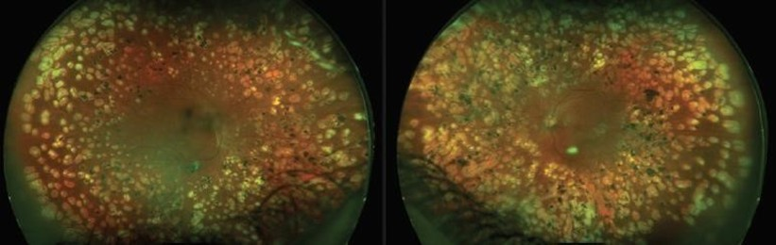

Fig 2.4 **Proliferative DR**

All the technical terms – MAs, hemorrhages, cotton wool spots, etc. can be easily visualized through figure 2.5.

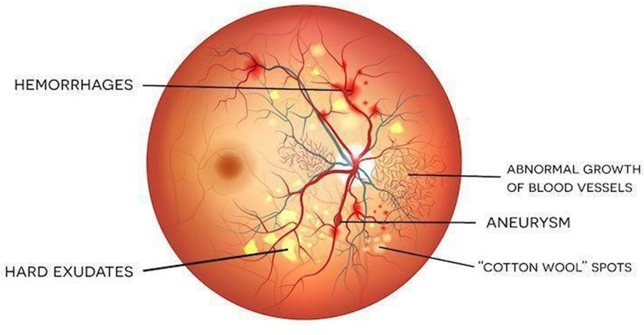

Fig 2.5 **DR conditions**

To understand more about various features and types of different DR’s, let’s look at table 2.1.

Table 2.1: Types and Features of different DR

|  |  |  |
| --- | --- | --- |
| **Classification** | **Alternative Terminology** | **Features** |
| Background DR | Mild/ moderate non proliferative DR | Hemorrhages Oedema MAs  Exudates  Cotton Wool Spots Dilated veins |
| Pre-proliferative DR | Severe/ very severe non proliferative retinopathy | Deep retinal hemorrhages in four quadrants Venous abnormalities  IRMA  Multiple cotton wool spots |
| Proliferative DR | PDR | New vessels on optic disc New vessels everywhere |
| Advanced Diabetic Eye Disease | Complications of Proliferative DR | Vitreous hemorrhage Retinal detachment  Neovascular glaucoma |

#### Existing Systems and Solutions

* + - * **Fundus Photography:** Fundus photography is the usage of fundus camera to photograph the region of the eye. Although the equipment for fundus photography can be easily accessible but a qualified ophthalmologist who can analyze the fundus images cannot. The population of diabetic patients is enormous, yet the total number of ophthalmologists is only 29 per 1 million people, indicating the need for a system that diagnoses DR automatically.
      * **Traditional Automated Works:** Much more work has been done in using computers to make automatic DR diagnoses. Traditional methods often deploy various feature extraction modules to first extract useful information from the fundus images and after that the extracted features are passed to classifiers such as the support vector machine, random forest classifier, etc. Such handmade feature-based methods are time consuming and often yield false results.
      * **Deep CNN:** Computer-aided diagnosis of DR has been explored in the past to reduce the burden on ophthalmologists and mitigate diagnostic inconsistencies between manual readers. Automated methods to detect MAs and reliably grade fundoscopic images of DR patients have been active areas of research in computer vision. The first ANNs explored the ability to classify patches of normal retina without blood vessels, normal retinas with blood vessels, pathologic retinas with exudates, and pathologic retinas with MAs. Now, with the advancement of technology and having powerful CNN structures in hand, one can explore and extend the boundaries of research and development, in the field of DR classification.

#### Research Findings for Existing Literature

The list of research papers studied by each member of our group to gather information about our project is given in Table 2.2.

Table 2.2: Research Findings for Existing Literature

|  |  |  |  |  |  |  |  |  |  |  |  |  |  |  |  |  |
| --- | --- | --- | --- | --- | --- | --- | --- | --- | --- | --- | --- | --- | --- | --- | --- | --- |
| **S.**  **No.** | | **Roll Number** | | | | | **Name** | **Paper Title** | | | **Tools/ Technology** | | | **Findings** | ***Citation*** | |
| 1 | | 102115004 | | | | | Pratinav Batra | **Epidemiology of diabetic retinopathy, diabetic macular edema and related vision loss.** | | | Large scale statistical analysis | | | Major trends in the prevalence, incidence, progression and regression of DR and DME are explored, and gaps in literature identified. | *R. Lee [1].* | |
| 2 | 102115004 | | | | Pratinav Batra | | | **Deep Learning Approach to Diabetic Retinopathy Detection** | | | Deep learning, Deep CNN, multi-target learning, ordinal regression, classification, SHAP, Kaggle, APTOS | Automatic deep learning b ased method for stage detection of DR by single photography of the human fundus. | | | *B. Tymchenko [2]* | |
| 3 | 102115004 | | | | Pratinav | | | **Classification** | | | Extracted findings from multiple sources to consolidate a conclusive theory. | ADA’s current clinical practice recommendatio ns, components of  diabetic care, general treatment goals and guidelines, and tools to evaluate quality of care. | | | *American* | |
|  |  | | | | Batra | | | **and Diagnosis** | | | *Diabetes [3]* | |
|  |  | | | |  | | | **of Diabetes:** | | |  | |
|  |  | | | |  | | | **Standards of** | | |  | |
|  |  | | | |  | | | **Medical Care** | | |  | |
|  |  | | | |  | | | **in Diabetes –** | | |  | |
|  |  | | | |  | | | **2024** | | |  | |
|  |  | | | |  | | |  | | |  | |
|  |  | | | |  | | |  | | |  | |
|  |  | | | |  | | |  | | |  | |
|  |  | | | |  | | |  | | |  | |
| 4 | 102115015 | | | | Paras | | | **The Four** | | | Extracted | Identification of DR using fundus images along with tips on caring for  patients with diabetes, including advice calibrated to the specific stages of DR. | | | *C. Koetting, [4]* | |
|  |  | | | | Sharma | | | **Stages of** | | | findings from |
|  |  | | | |  | | | **Diabetic** | | | multiple |
|  |  | | | |  | | | **Retinopathy** | | | sources to |
|  |  | | | |  | | |  | | | consolidate a |
|  |  | | | |  | | |  | | | conclusive |
|  |  | | | |  | | |  | | | theory. |
| 5 | 102115015 | | | | Paras Sharma | | | **Quadratic Kappa Metric**  **explained in 5** | | | Python, Data science libraries | Basic explanation of Quadratic | | | *A. Arora, [5]* | |
|  |  | | | |  | | | **simple steps | Kaggle** | | |  | Kappa Metric  and its  implementation  . | | |  | |
| 6 | | | 102115015 | | | Paras Sharma | | **Evaluation of a** | | Retrospective analysis of 10,000  consecutive patient visits, specifically exams – their retinal photographs, Inclusion/ exclusion criteria, Imaging protocol, Machine learning | | | Evaluated performance of a system for automated detection of DR in digital retinal photographs, built from published algorithms, in a large, representative, screening population. | | *M. D. Abramoff, [6]* |
|  | | |  | | |  | | **System for** | |  |
|  | | |  | | |  | | **Automatic** | |  |
|  | | |  | | |  | | **Detection of** | |  |
|  | | |  | | |  | | **Diabetic** | |  |
|  | | |  | | |  | | **Retinopathy** | |  |
|  | | |  | | |  | | **From Color** | |  |
|  | | |  | | |  | | **Fundus Photographs in a**  **Large** | |  |
|  | | |  | | |  | | **Population of** | |  |
|  | | |  | | |  | | **Patients with** | |  |
|  | | |  | | |  | | **Diabetes** | |  |
|  | | |  | | |  | |  | |  |
|  | | |  | | |  | |  | |  |
| 7 | | | 102115001 | | | Charvi | | **Iris – Diabetic** | | CNN, transfer | | | Use of CNNs | | *N. J. Philip [7]* |
|  | | |  | | | Sofat | | **Retinopathy** | | learning, | | | on color fundus | |  |
|  | | |  | | |  | | **Detection Software** | | GoogLeNet, AlexNet, ImageNet | | | images to  diagnose DR staging. | |  |
|  | | |  | | |  | |  | |  | | |  | |  |
|  | | |  | | |  | |  | |  | | |  | |  |
|  | | |  | | |  | |  | |  | | |  | |  |
|  | | |  | | |  | |  | |  | | |  | |  |
|  | | |  | | |  | |  | |  | | |  | |  |
|  | | |  | | |  | |  | |  | | |  | |  |
|  | | |  | | |  | |  | |  | | |  | |  |
|  | | |  | | |  | |  | |  | | |  | |  |
|  | | |  | | |  | |  | |  | | |  | | *.* |
| 8 | | | 102115001 | | | Charvi Sofat | | **A**  **Comprehensiv e**  **Guide to**  **Convolutional Neural** | | CNN | | | Brief explanation on CNN, pooling layers and convolutional layers. | | *S. Saha, [8]* |
|  | | |  | | |  | | **Networks –**  **the ELI5 way |** | |  | | |  | |  |
|  | | |  | | |  | | **by Sumit Saha** | |  | | |  | |  |
|  | | |  | | |  | | **|** | |  | | |  | |  |
|  | | |  | | |  | | **Towards Data** | |  | | |  | |  |
|  | | |  | | |  | | **Science** | |  | | |  | |  |
|  | | |  | | |  | |  | |  | | |  | |  |
|  | | |  | | |  | |  | |  | | |  | |  |
|  | | |  | | |  | |  | |  | | |  | |  |
| 9 | | | | 102115001 | | | Charvi Sofat | **Delving deep**  **into** | Use of rectifier neural networks for image classification | | | Based on the learnable activation and advanced  initialization, top-  5 test error of 4.94% was achieved on the ImageNet 2012 classification dataset, a 26% improvement over GoogLeNet. | | | *K. He, [9]* |
|  | | | |  | | |  | **Rectifiers: Surpassing Human-Level**  **Performance on**  **ImageNet Classification** |  |
|  | | | |  | | |  |  |  |
|  | | | |  | | |  |  |  |
|  | | | |  | | |  |  |  |
| 10 | | | | 102115012 | | | Varun | **Mastering the** | Deep Neural | | | Using ‘value | | | *D. Silver [10]* |
|  | | | |  | | | Kashyap | **game of Go** | Networks | | | networks’ to | | |  |
|  | | | |  | | |  | **with deep** |  | | | evaluate | | | *.* |
|  | | | |  | | |  | **neural**  **networks and tree search** |  | | | board  positions and ‘policy networks’ to select moves, the program | | | *.* |
|  | | | |  | | |  |  |  | | | was able to | | |  |
|  | | | |  | | |  |  |  | | | achieve | | |  |
|  | | | |  | | |  |  |  | | | 99.8% | | |  |
|  | | | |  | | |  |  |  | | | winning rate. | | |  |
|  | | | |  | | |  |  |  | | |  | | |  |
|  | | | |  | | |  |  |  | | |  | | |  |
|  | | | |  | | |  |  |  | | |  | | |  |
|  | | | |  | | |  |  |  | | |  | | |  |
|  | | | |  | | |  |  |  | | |  | | |  |
|  | | | |  | | |  |  |  | | |  | | |  |
|  | | | |  | | |  |  |  | | |  | | |  |
|  | | | |  | | |  |  |  | | |  | | |  |
|  | | | |  | | |  |  |  | | |  | | |  |
|  | | | |  | | |  |  |  | | |  | | |  |
|  | | | |  | | |  |  |  | | |  | | |  |
|  | | | |  | | |  |  |  | | |  | | |  |
|  | | | |  | | |  |  |  | | |  | | |  |
|  | | | |  | | |  |  |  | | |  | | |  |
|  | | | |  | | |  |  |  | | |  | | |  |
|  | | | |  | | |  |  |  | | |  | | |  |
| 11 | | | | 102115012 | | | Varun Kashyap | **Automated Identification of Diabetic**  **Retinopathy**  **Using Deep Learning** | Data driven Deep Learning Algorithms | | | A fully datadriven Artificial intelligencebas ed grading algorithm can be used to screen fundus photographs obtained from diabetic patients and to identify, with high reliability, which cases should be referred to an ophthalmologist for further evaluation and  treatment. | | | *R. Gargeya [11]* |
| 12 | | | | 102115001 | | | Varun Kashyap | **Retinopathy and Mortality** | Large Scale Statistical Analysis | | | Both mild and moderate/ severe retinopathy were associated with increased allcause mortality risk in unadjusted and adjusted models. | | | *E. Frith [12]* |
| 13 | | | | 102115104 | | | Vaibhav Kalra | **APTOS 2024**  **Blindness Detection** | Dataset | | | 5590 images collected in rural areas to help identify DR  automatically. | | | *Asia Pacific [13].* |
| 14 | | | | 102115104 | | | Vaibhav Kalra | **Automated detection of diabetic retinopathy: barriers to translation into clinical practice** | Expert system, Image analysis | | | Automated identification of DR from colored images of the retina has enormous potential to increase the quality, costeffectivene ss and accessibility of preventive care for people with diabetes. | | | *M. D. Abramoff,*  *[14]* |
| 15 | | | | 102115104 | | | Vaibhav Kalra | **Aflibercept Injection** | Animal and Human Trials. | | | There are various side effects associated with the drug, including but not limited to headache, itchy eyes and nausea. | | | *“Aflibercept Injection [15]* |

According to our review of the literature, recent research on diabetic retinopathy (DR) diagnosis and management showcases various approaches. Lee et al. explore trends in the prevalence and progression of DR and diabetic macular edema (DME), identifying critical gaps in the literature [1]. The American Diabetes Association provides comprehensive clinical guidelines for DR care [3], while Koetting offers insights on managing DR stages using fundus imaging [4]. Automated detection systems are a key focus, with Tymchenko et al. demonstrating the effectiveness of deep learning models for DR stage detection using fundus photography [2], and Abramoff et al. evaluating an automated system's reliability in large patient populations [6]. Philip and colleagues further enhance diagnostic capabilities through convolutional neural networks applied to fundus images [7]. Gargeya and Leng highlight the potential of AI-driven algorithms to streamline DR screening [11], complementing Frith’s findings that link DR severity with increased mortality risk [12]. Additionally, research on treatment options, such as Aflibercept, notes both therapeutic benefits and side effects [15]. Collectively, these studies emphasize the advancements in automated detection, clinical guidelines, and treatment strategies for improving DR management.

#### Problem Identified

To automate the diagnosis of DR and provide appropriate suggestions to DR patients by training deep CNN model to grade the severities of DR fundus images.

The goal here is to build an image classification model which can take a look at the images and classify the image into one of the 5 classes (0, 1, 2, 3, 4). This image classification model will accelerate the process of blindness detection in patients. Currently doctors review the image and classify it into one of the classes.

0 – No DR, 1 – Mild, 2 – Moderate, 3 – Severe, 4 – Proliferative DR

### Research gaps

DR is one of the most threatening complications of diabetes that leads to permanent blindness if left untreated. One of the essential challenges is early detection, which is very important for treatment success. Unfortunately, the exact identification of the DR stage is notoriously tricky and requires human interpretation of fundus images. Simplification of the detection step is crucial and can help millions of people.

Traditional methods used for DR detection in medical literature included feature extraction from images – fit an SVM classifier; applying PCA to images – apply DTs, NB classifiers, etc. The best results obtained are approximate to 75% accuracy.

Convolutional Neural Networks (CNNs) have been effectively used for diagnosing diabetic retinopathy (DR), employing architectures like ResNet50, InceptionNetV3, and DenseNets to achieve up to 81% accuracy in feature extraction from images. However, the high cost of labeled datasets and inconsistencies among doctors hinder their performance. Our project proposes an automatic deep-learning method for detecting DR stages using a single fundus photograph, aimed at early screening and detection of the disease.

# CHAPTER 3 PROBLEM FORMULATION AND ADJECTIVE

# 

Diabetic retinopathy (DR) is a serious complication of diabetes that damages the retina’s blood vessels, potentially leading to blindness. Despite advances in treatment and diagnostic methods, significant challenges remain:

* **Early Detection**: Current diagnostic tools often miss early stages of DR, delaying critical intervention.
* **Diagnostic Accuracy**: Existing imaging techniques can be subjective and dependent on clinician expertise.
* **Personalized Treatment**: Standard treatments do not account for individual patient differences, affecting efficacy.
* **Accessibility**: Many patients face barriers to regular screening and treatment, such as high costs and limited access to care.

Our team will be designing a website to which users/ patients can upload an image of their retina and get information about what degree of DR they are at currently. Machine learning will use CNN to categorize the uploaded image. The website will be coded in HTML, CSS and JavaScript and deployed using Flask. Each image, after processing will be categorized into any one of the following DR stages:

* Normal
* Mild
* Moderate
* Severe
* Prolific

Any unrecognizable images will be rejected. There’ll be a reasonable limit to image size, and a stable internet connection will be required. User’s images will not be stored in the database for privacy reasons. The CNN model will be trained on a dataset of pre-processed images of the fundus.

The final project would combine the Machine Learning model of CNN, written in Python3, with the website to provide the facility online.

By enhancing early detection, diagnostic accuracy, personalized treatment, and accessibility, this study aims to improve patient outcomes and reduce the burden of diabetic retinopathy.

**Objectives**

The aim of the project is to design DR diagnostic website such that:

* The website is able to take images from users.
* The website is able to successfully categorize the uploaded images into five stages of DR using CNN.
* The classification happens at an accuracy of at least 65%
* Website is able to return classification results from CNN in under a few seconds seconds.
* The website is able to completely function under standard internet speed.

# CHAPTER 4 PROJECT DESIGN AND DESCRIPTION



### Description

#### Project Perspective

Our objective with this project is to automate the diagnosis of DR and provide appropriate suggestions to DR patients by training a deep CNN model to grade the severities of DR fundus images. We have implemented the use of convolutional networks and image processing to analyze the image and successfully detect the stage of DR that the patient is currently suffering from.

#### Project Features

We will create and host an online platform or portal which can be used by various hospitals for its different patients. The patient would need to have a registration ID and password that would be provided by the hospital that is using our services. When the patient or the doctor using the portal would sign in using valid credentials, they would have the option to upload the image of the retina on our portal. This image of the retina would be passed on to our trained model which uses convolutional networks and image processing to analyze and dissect the image to detect the stage of DR that the patient is suffering from. These results would then be displayed on the portal and then the hospital can take appropriate measures to help the patient.

#### Data Flow Diagram

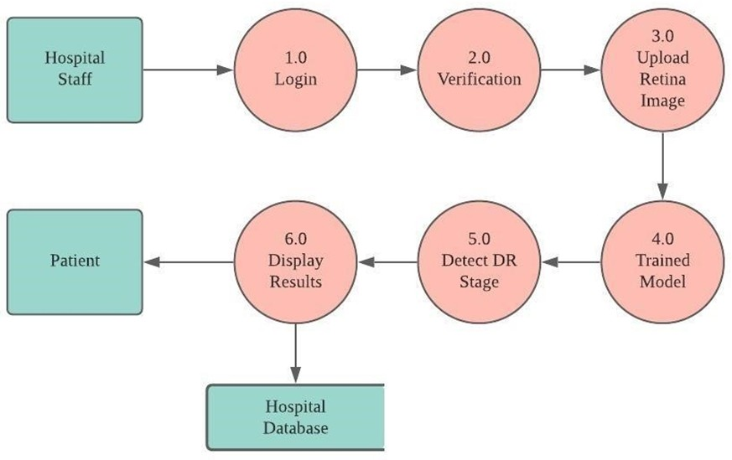In Fig 4.1, we will understand the Data flow with help of a flow chart

Fig 4.1 Data flow diagram

### System architecture

#### Tier Architecture

A well explained 3-tier architecture is given in fig 4.2

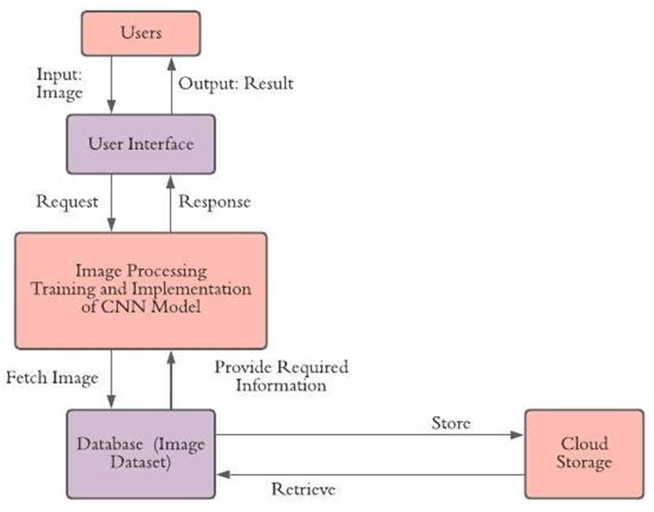

Fig 4.2 Three tier architecture

#### Sequence diagram

In Fig 4.3, we can see how the process is executed between different layers of our model in a hospital.

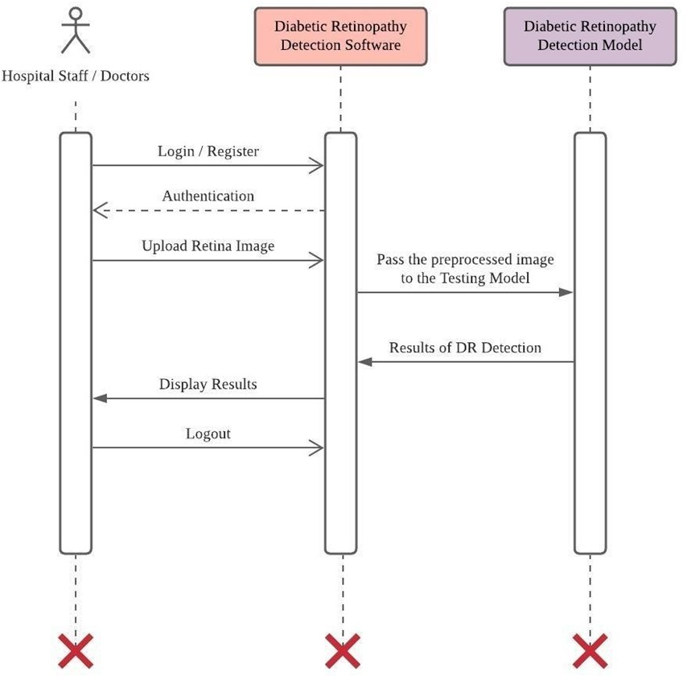

Fig 4.3 Sequence diagram

#### Activity diagram

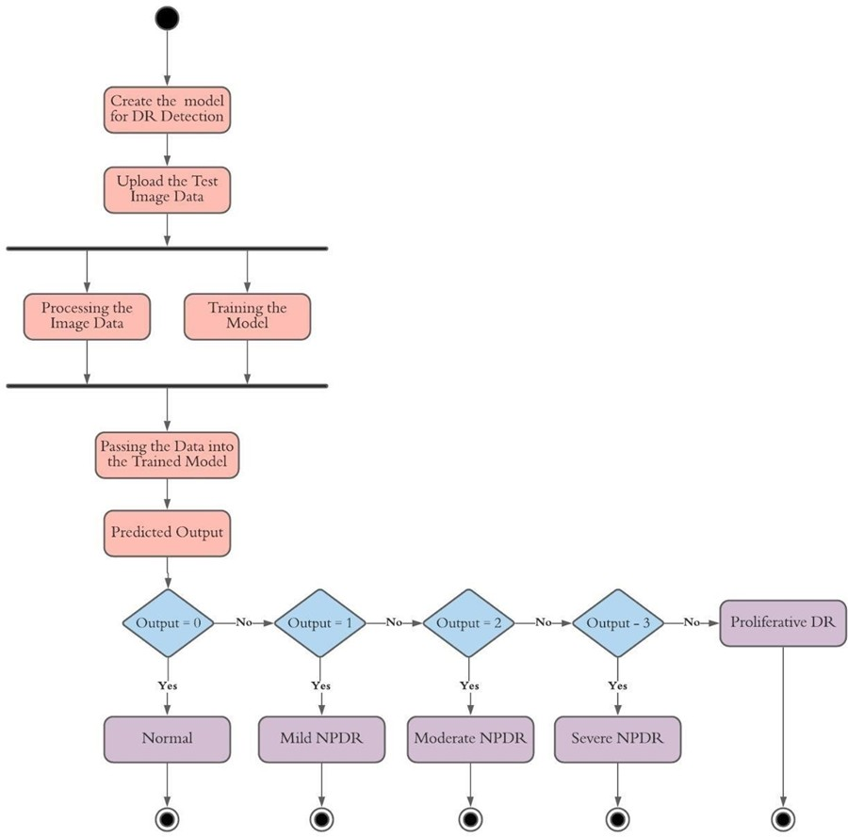In Fig 4.4, we will look at how the model will process a given input and return the result.

Fig 4.4 Activity diagram

#### Class diagram

In Fig 4.5, we will look at the class diagram of the model.

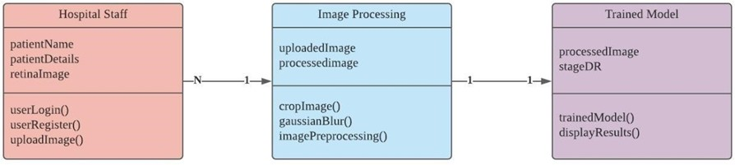

Fig 4.5 Class diagram

#### State chart diagram

A state chart diagram is shown in Fig 4.6 to understand the steps involved in any application.

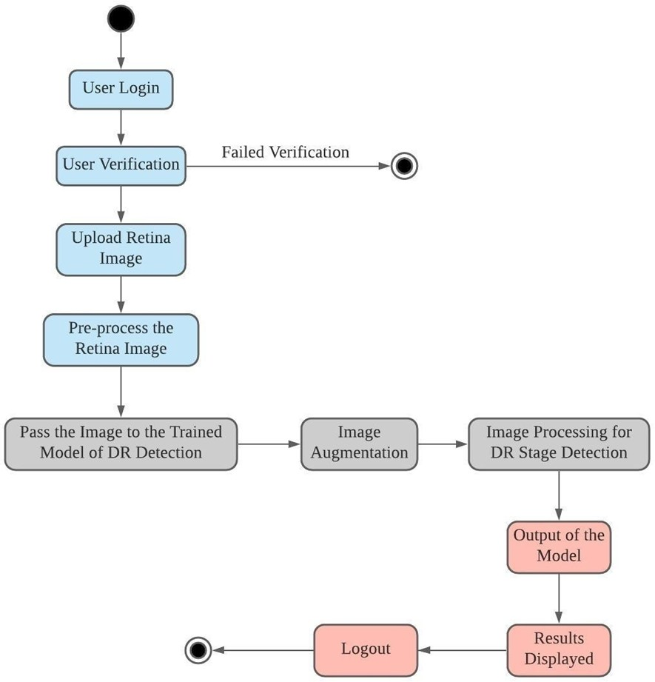

Fig 4.6 State chart diagram

#### User interface diagram

In Fig 4.7, user interface diagram is provided which shows how a interface would look from the user end and from developer end.

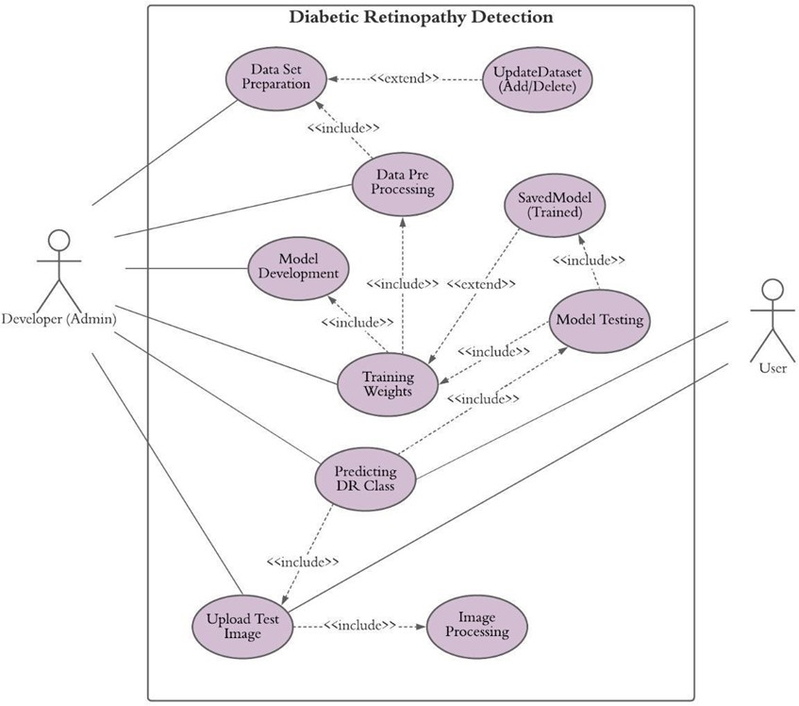

Fig 4.7 User interface diagram

### 4.3 Tools and Technologies used

* **Google Colaboratory:** Google Colaboratory or “Colab” for short, is a product from Google Research. Colab allows anybody to write and execute arbitrary python code through the browser, and is especially well suited to machine learning, data analysis and education.
* **Jupyter Notebook:** Jupyter is a free, open-source, interactive web tool known as a computational notebook, which researchers can use to combine software code, computational output, explanatory text and multimedia resources in a single document.
* **Dataset used:** APTOS 2019 Blindness Detection – We are given eye images and their corresponding severity scale which is one of [0, 1, 2, 3, 4]. This data is being used for training the model and prediction is to be done on the test data.
* **Machine Learning:** Machine learning is the scientific study of algorithms and statistical models that computer systems use to perform a specific task without using explicit instructions, relying on patterns and inference instead.
* **Deep Learning:** Deep learning is a type of machine learning, which is a subset of artificial intelligence. Machine learning is about computers being able to think and act with less human intervention; deep learning is about computers learning to think using structures modelled on the human brain. Concepts like CNN, ANN, Batch Normalisation, Dropout, Max Pooling, Adam Optimizer, Activation functions – relu and softmax were used.
* **Model Architecture:** Task learning Model (as it parallelly does training for Regression, Classification, Ordinal Regression); CNN Architecture – ResNet50, EfficientNetB4
* **Data Science Tools and Libraries**: Python, Warnings, Pandas, Numpy TQDM, PrettyTable, Pickle, OS, Sklearn, Seaborn, Matplotlib, PIL, CV2 (OpenCV), Keras, etc.
* **Image Preprocessing and Augmentations:** Image cropping and resizing was used. Spurious correlations between the output class label and several image meta-features, e.g., resolution, crop type, zoom level, or overall brightness. Image Augmentations were used.

### UG subjects

* Machine Learning
* Software engineering
* Python
* Data Communication
* DataBase Management Systems

### Standards used

830-1998 – IEEE Recommended Practice for Software Requirements Specifications.

Replaced by ISO/ IEC/ IEEE 29148:2011. The content and qualities of a good SRS are described and several sample SRS outlines are presented. This recommended practice is aimed at specifying the requirements of software to be developed but also can be applied to assist in the selection of in-house and commercial software products. Guidelines for compliance with IEEE/ EIA 12207.1 – 1997 are also provided.

To achieve harmonization of the content definition for software life cycle process results among the IEEE software engineering standards and with related international standards. This will help users to produce results consistent with the international standard for software life cycle processes, ISO/ IEC 12207.

* TCP/ IP suite: for communication with internet
* Nifti, Minc, Dicom, JPEG, JPG: Medical Image File formats
* Python3: CNN Model
* CSS, HTML, JS: Website Design
  + **IEEE 11073-10207-2017**: IEEE Standard for Service-Oriented Medical Device Exchange Architecture & Protocol Binding.
* Defines an interoperable architecture for medical devices used in healthcare settings.
* Focuses on communication protocols to enable plug-and-play integration, facilitating real-time data exchange between devices and systems.
* Widely used for personal health monitoring devices (like glucose meters, blood pressure monitors) and ensures compatibility across manufacturers and platforms.
  + **IEEE 42010-2011**: IEEE Standard for Systems and Software Engineering
* Provides guidelines on documenting and describing system architectures in engineering projects.
* Ensures that software and hardware systems are designed with a clear, structured architecture, improving collaboration and traceability across teams.
  + **IEEE 1599-2008**: IEEE Standard for Signal Processing and Analysis of Electroretinograms
* Establishes best practices for capturing, analyzing, and interpreting ERGs, which measure electrical responses of the retina to light stimuli.
* Helps in early detection of retinal disorders such as retinitis pigmentosa and glaucoma by standardizing testing procedures.
  + **IEEE 1073-2008**: IEEE Standard for Health Informatics
* Enables secure and consistent transmission of data from medical devices (such as ventilators, infusion pumps) to healthcare information systems.
* Aims to improve patient safety and streamline workflows by ensuring seamless communication between devices and clinical records.
  + **IEEE 1855-2016**: IEEE Standard for Learning Technology
* Supports adaptive learning systems that can adjust content and evaluation criteria based on the learner’s needs.
* FML allows modelling a fuzzy logic system in a human-readable and hardware independent way. FML is based on eXtensible Markup Language (XML).
  + **IEEE 2432-2017**: IEEE Standard for Verilog Register Transfer Level (RTL) Synthesis
* Defines guidelines and constraints to ensure that designs are accurately translated from high-level models to hardware implementations.
* Essential for designing integrated circuits (ICs) and field-programmable gate arrays (FPGAs), ensuring performance, functionality, and compatibility across tools and platforms.

# CHAPTER 5 OUTCOME AND PERSPECTIVE LEARNING



### Scope and outcomes

#### Project scope

The model will be able to detect DR and successfully classify the detected retinopathy to different stages for proper treatment. It would also be accessible from a web application in a reasonable time frame. The model will be a cost-effective solution for DR, and will be able to help improve patients’ outcomes by providing early detection and treatment. We hope that this portal would be used to help the patients of different renowned hospitals who are able to deploy this on their network with ease.

#### Project outcome

To diagnose the stage of DR for the user’s fundus images to perform desired tasks such as:

* + - * Open the website and successfully register/ log in.
      * Uploading image on portal.
      * Users can view the results, etc.
      * CNN becomes better as it categorizes more images.
      * Hospitals are less congested.
      * Patients that absolutely require in-person attention from doctors don’t have to wait as long.
      * Users are able to get diagnosed from anywhere in almost no time and free of cost.

Deliverables:

* + - * The user’s image is successfully categorised into one of the five DR categories.

### Prospective learning

#### Deep Learning and Neural Networks:

Understanding the architecture and functioning of Convolutional Neural Networks (CNNs). Learning to build, train, and fine-tune neural networks for image classification tasks. Experience with advanced neural network architectures and transfer learning techniques.

#### Medical image processing:

Acquiring knowledge on pre-processing medical images, including techniques such as resizing, normalisation, and augmentation. Learning to handle and interpret fundus images specifically used for diagnosing diabetic retinopathy.

#### Data Handling and Annotation:

Skills in collecting, organising, and managing large datasets of medical images. Understanding the importance of labelled data and techniques for annotating medical images.

#### Software and Tools:

Gaining proficiency with deep learning frameworks like TensorFlow, Keras, or PyTorch. Using tools for image processing such as OpenCV or PIL.

#### Deployment:

Learning to deploy machine learning models to production environments. Experience with web deployment frameworks (e.g., Flask, Django) and cloud services (e.g., AWS, Azure, Google Cloud).

#### Automation and Scalability:

Understanding how to automate the process of image analysis and diagnosis to handle large-scale data efficiently. Learning to design systems that can scale to accommodate increased usage. Domain Knowledge.

#### Medical Knowledge:

Gaining insights into diabetic retinopathy, its stages, and the clinical importance of early detection. Understanding how AI and machine learning can be integrated into healthcare for improved diagnostics.

### Conclusion

DR cannot be cured. To prevent vision loss, laser analysis is usually very effective if it is done before it adversely harms the retina. Our model will help in the early detection of DR at a very reasonable cost. The model that we shall be developing can be tagged as a great detector to detect whether a person has DR or not automatically by using the eyes’ fundus photographs. It will correctly identify the different stages such as Normal, Mild DR, Moderate DR, Severe DR or Proliferative DR.

# CHAPTER 6 PROJECT TIMELINE



### Work breakdown

Fig 6.1 explains to us the work breakdown structure of Diabetic Retinopathy detection system.

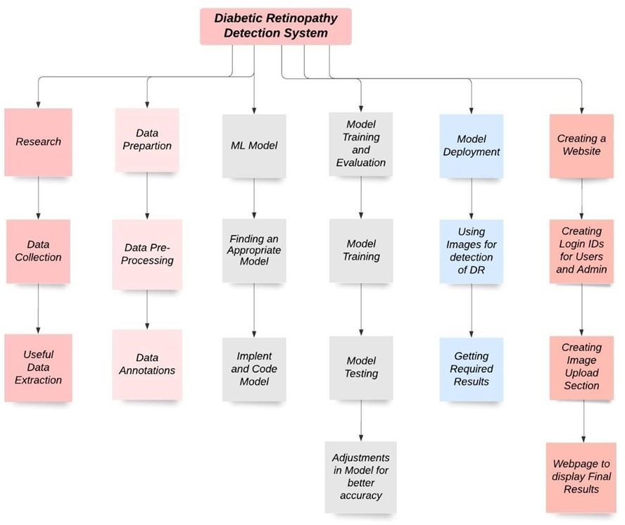

Fig 6.1 Work breakdown structure

### Project timeline

From table 6.1, we can understand the monthly execution of the work.

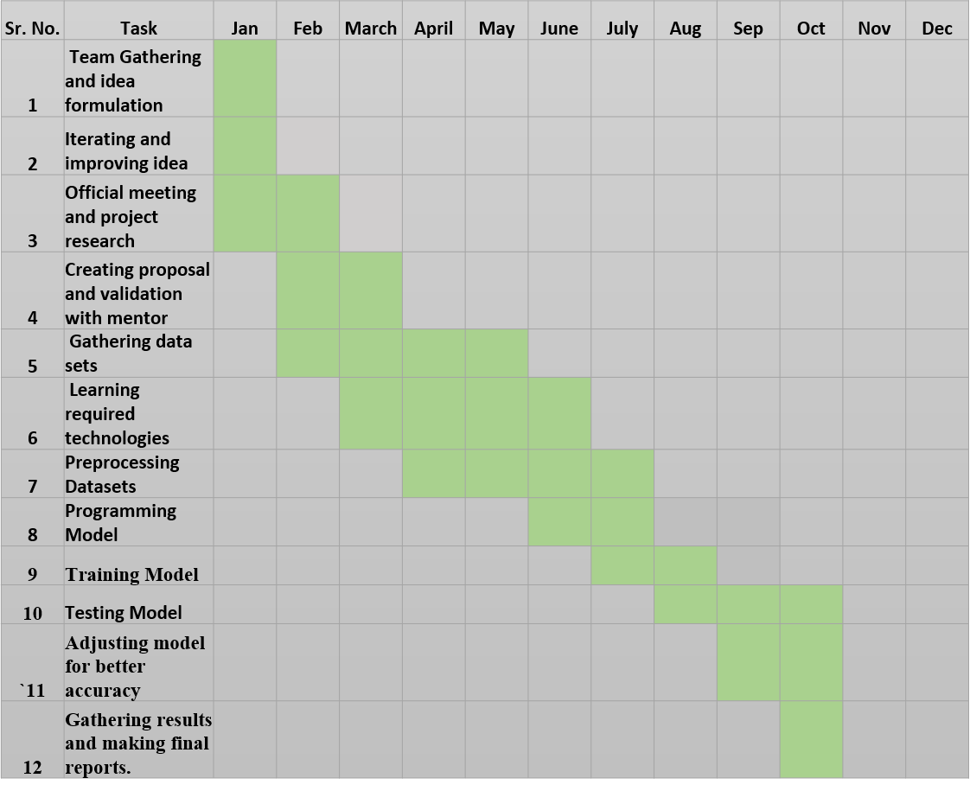

Table 6.1 PROJECT TIMELINE

### Individual GANTT chart

Figure 6.2 shows the work done by each member of the team.

|  |  |  |  |  |  |  |
| --- | --- | --- | --- | --- | --- | --- |
| **S.No** | **Task** | **Pratinav** | **Charvi** | **Varun** | **Paras** | **Vaihav** |
| **1.** | **Literature Survey** | **✔** | **✔** | **✔** | **✔** | **✔** |
| **2.** | **Gathering data sets** | **✔** |  |  | **✔** | **✔** |
| **3.** | **Searching for required platforms** | **✔** |  |  | **✔** |  |
| **4.** | **Learning required technology** |  | **✔** | **✔** |  |  |
| **5.** | **Pre processing data sets** |  | **✔** | **✔** |  | **✔** |
| **6.** | **Programing model** |  |  | **✔** |  |  |
| **7.** | **Training model** |  | **✔** |  | **✔** | **✔** |
| **8.** | **Gathering results and research** |  |  |  | **✔** | **✔** |
| **9.** | **Final research and report making** | **✔** | **✔** | **✔** | **✔** | **✔** |

Figure 6.2 Individual work breakdown

# CHAPTER 7 CONCLUSION AND FUTURE WORK

# 7.1 Conclusions

# DR cannot be cured. To prevent vision loss, laser analysis is usually very effective if it is done before it adversely harms the retina. Our model will help in the early detection of DR at a very reasonable cost. The model that we shall be developing can be tagged as a great detector to detect whether a person has DR or not automatically by using the eyes’ fundus photographs. It will correctly identify the different stages such as Normal, Mild DR, Moderate DR, Severe DR or PDR.

# 7.2 Environmental, Economic and Societal Benefits

# Automated identification of DR, which is the primary cause of blindness and visual loss for those ages 18-65 years, from images of the retina has enormous potential to increase the quality, cost-effectiveness and accessibility of preventive care for people with diabetes.

# The current challenge is to make early detection more accessible by reducing the cost and manpower required, while maintaining or improving DR detection quality. This challenge can be met by automated detection of DR in retinal images. To examine 100,000 patients screening of retinal images by a human grader can take a long time if he/ she can evaluate 8-12 patients per hour whereas the automatic system will be very beneficial to examine them within a very less time as compared to the human grader.

# Automatic DR has potential to provide cost savings, especially in low-income populations and rural patients with high transportations costs. Generally, charges of $30 - $60 for screening retinal photography are common which may increase depending upon the region where it is performed.

# Multiple patient barriers to DR screening exist, including poor access to care, lack of time, high out-of-pocket expenses, insufficient patient knowledge and awareness of DR especially among low-income populations, and ethnical minorities. These barriers are further magnified among developing countries.

# 

# 7.3 Future Work

# The Automated screening system developed here significantly reduces the time required to determine diagnoses, saving effort and costs for ophthalmologists and result in the timely treatment of patients. Therefore, this system for DR detection plays a vital role in detecting DR at an early stage. Though our model works perfectly well for the binary classification, it still provides less accurate results for the multiclassification. Even the DCNN architecture like Efficient Net models, provided similar results to the multiclassification in the study above. After conducting all the necessary techniques and experiments with the model training, one can directly match the core reason of the problem faced above, to the limitation in the availability of good quality fundus images. For training an intelligent model, like presented here, to be extremely accurate for multiclassification, the availability of a large dataset with good quality images is a must requirement. Due to the recent increased accessibility of technologically advanced camera devices in most of the locations, one can expect the dataset available till now on the internet to consist of a lot of noisy images captured with poor devices. Also, for building a strong intelligent model with such a large dataset, one will require more powerful machines and features like GPU and 58 RAM, to train a model in a decent time duration. Thus, for future work, after meeting these requirements one can further extend the model accuracy to some extent by using more powerful DCNN models like Efficient Net models, Alex Net models, ResNet models, etc. The plan is to create the new labelled dataset from the single capturing source so that the noise in the dataset can be reduced and our model will be able to learn more complex features resulting in better overall performance accuracy.

# REFERENCES



[1]R. Lee, T. Y. Wong, and C. Sabanayagam, "Epidemiology of diabetic retinopathy, diabetic macular edema and related vision loss," *Eye and Vision*, vol. 2, pp. 1-25, 2015.

[2] B. Tymchenko, P. Marchenko, and D. Spodarets, "Deep learning approach to diabetic retinopathy detection," *arXiv preprint* arXiv:2003.02261, 2020.

[3] American Diabetes Association Professional Practice Committee, "2. Diagnosis and Classification of Diabetes: Standards of Care in Diabetes-2024," *Diabetes Care*, vol. 47, Suppl. 1, pp. S20-S42, Jan. 2024, doi: 10.2337/dc24-S002.

[4] C. Koetting, “The Four Stages of Diabetic Retinopathy,” *Modern Optometry*, no. June, pp. 21–24, 2019.

[5] S. Vanbelle, "A new interpretation of the weighted kappa coefficients," *Psychometrika*, vol. 81, no. 2, pp. 399-410, 2016.

[6] M. D. Abràmoff, M. Niemeijer, M. S. A. Suttorp-Schulten, M. A. Viergever, S. R. Russell, and B. van Ginneken, "Evaluation of a system for automatic detection of diabetic retinopathy from color fundus photographs in a large population of patients with diabetes," *Diabetes Care*, vol. 31, no. 2, pp. 193–198, Feb. 2008.

[7] N. J. Philip, R. Roji, R. Jose, R. Cherian, and Dr. A. K. S., "Iris – Diabetic Retinopathy Detection Software," *International Journal of Engineering Research & Technology (IJERT)*, vol. 9, no. 10, Oct. 2020.

[8] S. Saha, "A comprehensive guide to convolutional neural networks—the ELI5 way," *Towards Data Science*, no. 15, 2018.

[9] K. He, X. Zhang, S. Ren, and J. Sun, "Delving deep into rectifiers: Surpassing human-level performance on ImageNet classification," in *Proc. IEEE Int. Conf. Comput. Vis.*, pp. 1026-1034, 2015.

[10] D. Silver et al., "Mastering the game of Go with deep neural networks and tree search," *Nature*, vol. 529, no. 7587, pp. 484-489, 2016.

[11] R. Gargeya and T. Leng, "Automated identification of diabetic retinopathy using deep learning," *Ophthalmology*, vol. 124, no. 7, pp. 962-969, 2017.

[12] E. Frith and P. D. Loprinzi, "Retinopathy and mortality," *Diabetes Spectrum*, vol. 31, no. 2, pp. 184-188, 2018.

[13] M. Karthik and S. Dane, *APTOS 2019 Blindness Detection*, Kaggle, 2019. [Online]. Available: <https://kaggle.com/competitions/aptos2019-blindness-detection>

[14] M. D. Abramoff, M. Niemeijer, and S. R. Russell, "Automated detection of diabetic retinopathy: barriers to translation into clinical practice," *Expert Review of Medical Devices*, vol. 7, no. 2, pp. 287-296, 2010.

[15] M. D. Abramoff, M. Niemeijer, and S. R. Russell, "Automated detection of diabetic retinopathy: barriers to translation into clinical practice," *Expert Review of Medical Devices*, vol. 7, no. 2, pp. 287-296, 2010.

[16] "Diabetic Retinopathy Market Analysis Report by Type (Proliferative DR, Non-Proliferative DR), By Management (Anti-VEGF Therapy, Intraocular Steroid Injection, Laser Surgery, Vitrectomy), And Segment Forecasts, 2018 – 2025," *Grand View Research*, Feb. 2018. [Online]. Available: <https://www.grandviewresearch.com/industry-analysis/diabetic-retinopathy-market>

[17] World Health Organization, "Strengthening diagnosis and treatment of Diabetic Retinopathy in SEA Region," *World Health Organization, Regional Office for South-East Asia*, 2020. [Online]. Available: <https://apps.who.int/iris/handle/10665/334224>

[18] "Diabetic Retinopathy," *National Eye Institute*, Aug. 3, 2019. [Online]. Available: <https://www.nei.nih.gov/learn-about-eye-health/eye-conditions-and-diseases/diabetic-retinopathy>

[19] M. C. Staff, "Diabetic retinopathy – Diagnosis and treatment – Mayo Clinic," *Mayo Clinic*, Jun. 24, 2021. [Online]. Available: <https://www.mayoclinic.org/diseases-conditions/diabetic-retinopathy/diagnosis-treatment/drc-20371617>

[20] "Ranibizumab Injection: MedlinePlus Drug Information," *MedlinePlus*, Apr. 15, 2015. [Online]. Available: <https://medlineplus.gov/druginfo/meds/a607044.html>

[21] "Aflibercept Injection: MedlinePlus Drug Information," *MedlinePlus*, Jul. 15, 2019. [Online]. Available: <https://medlineplus.gov/druginfo/meds/a612004.html>